All **FIVE** magnets should be placed properly on the vehicle before we leave the parking spot. 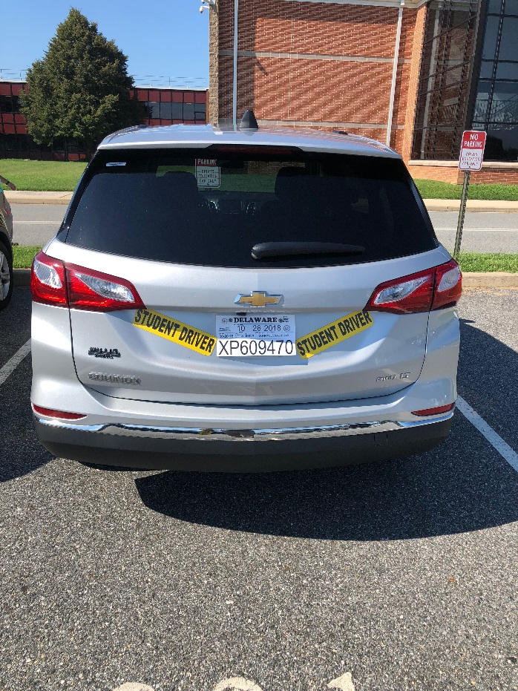



INSIDE OF OUR CAR

Use the buttons on the left side of your seat to adjust up/down, forward and backward.

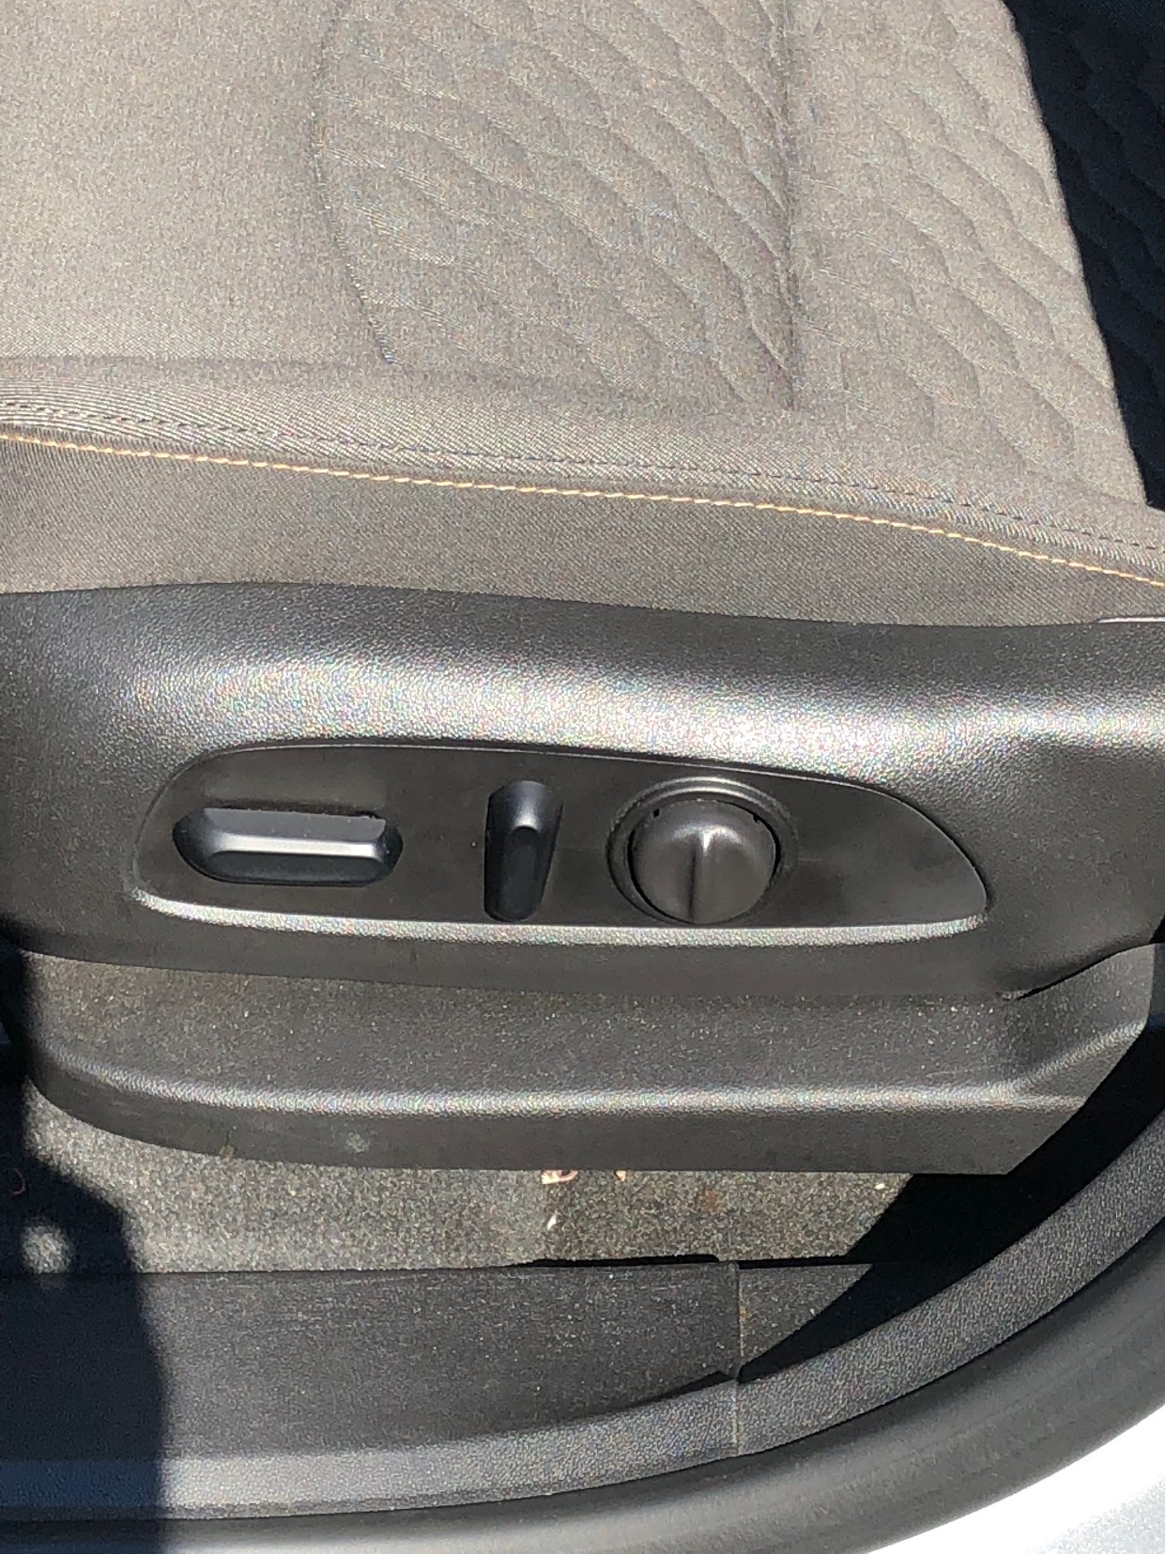

To adjust mirrors push either the left or right button.

Then adjust the side mirrors by pushing the circle button Left/Right and Up/Down.

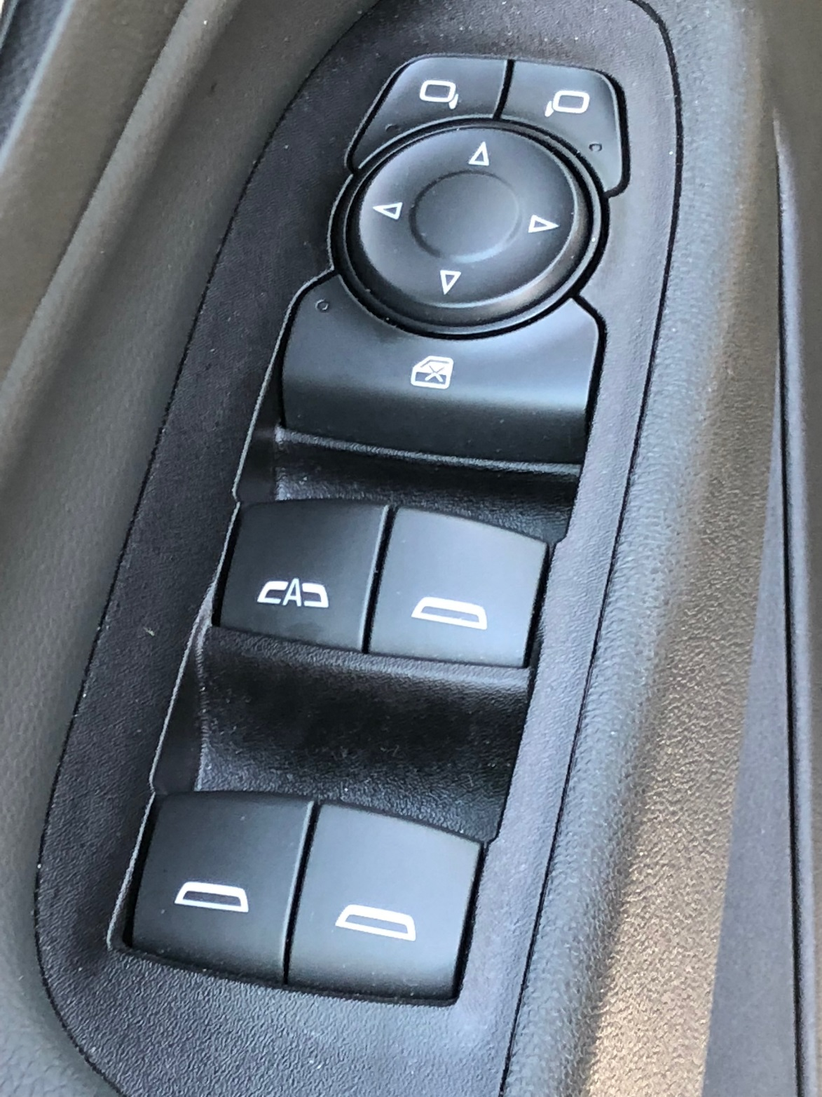

Dashboard and center console

